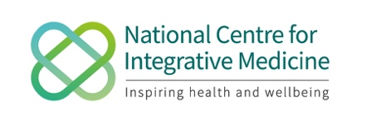
Child and Family Health: Creating Vitality

Date: Friday 16 October 2020
Time: 10.00-5.00pm
Venue: Zoom

TIME | CONTENT | SPEAKER
10.00 - 10.10 | Welcome Address | Dr Elizabeth Thompson  CEO for the National Centre for Integrative Medicine
10.10 - 10.50 | Keynote speaker  Bristol’s Approach to Integrative Care in Childhood Obesity  Q and A | Professor Julian Hamilton-Shield  Professor of Diabetes and Metabolic Endocrinology/ Paediatrician
10.50-11.25 | Osteopathy in Child Health from Baby to Adolescent  Q and A | Peter Cockhill  Osteopath
11.25– 11.55 | BREAK
11.55 - 12.30 | Find Your Village: Promoting Child Development and Wellbeing in Migrant Communities  Q and A | Dr Tom Allport  Consultant Paediatrician
12.30 - 1.00 | Nutrition, Child Health and Activating Health | Anita Beardsley  Nutritional Therapist
1.00 - 2.00 | Cook your own LUNCH with demo - then eat! | Anita Beardsley  Nutritional Therapist
2.00 - 2.40 | A Greener CAMHS: Keeping Nature in Mind  Q and A | Dr Catriona Mellor  Child and Adolescent Psychiatrist
2.40 – 3.10 | Integrative General Practice  Q and A | Dr Frank Mulder  GP and Anthroposophical Doctor
3.10 – 3.40 | Farming, Family, Therapy and A Holistic Approach to Child Health  Q and A | Tish Feilden/Beth Walker, Therapy Coordinator/OT at Jamie’s Farm
3.40 - 4.00 | BREAK
4.00 – 4.45 | Keynote Speaker  Integrative Paediatrics in the United States: Teaching the Art of Thriving in Childhood  Q and A | Dr Hilary McClafferty  Integrative Paediatrician, USA
4.45 - 5.00 | Close | Dr Elizabeth Thompson  CEO for the National Centre for Integrative Medicine

